**Kickstart My Chart**

Conclusions

* In terms of industry, performing arts have a dominate presence on the Kickstarter platform. Film & Video, Theater & Music represent 63% of the total campaign count. Conversely, Journalism is by far the least popular industry holding less than one percent of the total count, none of which having any success (all cancelled).
* In the US, Technology is the leading industry in terms of Percent Funded at 77%, however the amount pledged for Cancelled and Failed campaigns is more than all the other categories combined ($3.0M of $4.1M total).  
    
  If you were to rank the categories in terms of total goal for **cancelled and failed** projects, you’d find Technology 4th on the list at $17.7M. A very distant 4th in fact. Film & Video is first with **$115.4M.**So we’re looking at $3.0M in pledged money toward $17.7M in goals for Technology campaigns that aren’t successful. For Film & Video, a measly **$190K** is pledged.  
    
  This shows that backers are more comfortable supporting Technology over Film & Video.
* X

Dataset Limitations

* ‘Percent Funded’ & ‘Average Donation’ are derived measures and cannot be used in a PivotTable without risk of aggregation error, which is limiting from an analytical perspective (for example, you could not use this field in a pivot table at the Category or Subcategory level, it is only useful at the individual ID level). Using a calculated measure would be a more extensible approach.
* ‘Goal’ & ‘Pledged’ fields cannot be aggregated and analyzed at a topline level as they are recorded in relation to the country of origin. FOREX rates would need to be added to the dataset in order to perform any topline financial analysis beyond an individual country.
* ‘backers_count’ appears to be capturing the total number of backers for an individual project (because they’re unique records in the dataset). A key component we’re missing is the country of origin for backers, which could potentially unveil some intriguing insights (ie Americans funding Chinese campaigns, or vice versa). Because Kickstarter markets the ability to pledge internationally, it’d be interesting to know the volume of this activity.

Additional tables & graphs

* Data table showing category rank for key metrics (example below, can only be used with an individual country specified)  
  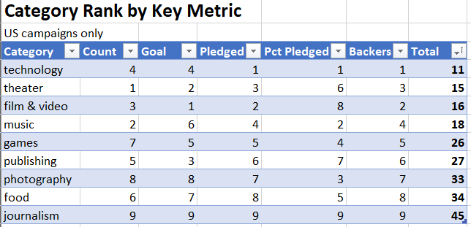
* Data table showing campaign count by country and state (sorted largest to smallest)  
  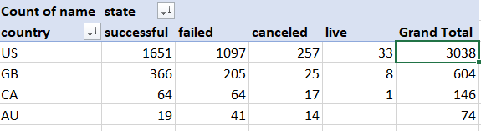
* X